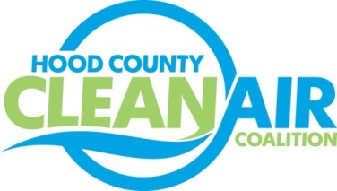
Meeting: Tuesday, November 5, 2013
American Town Hall
220 N. Travis Street, Granbury, Texas 76048
10:00-11:00 a.m.

Agenda

- Call Meeting to Order
- Updates - Michelle McKenzie
  - Green Apple School Day of Service poster contest judging
  - Natural Gas Workshop update
  - Idling Reduction Technology follow up
  - Ozone Advance Workshop summary
  - CenSara Conference Call
  - Clean Energy CNG Station in Irving
  - Rider 8
    - TCEQ meeting summary
    - Work Plan summaries
- Discussion
- Adjourn

